Addition

Key vocabulary: Add, addition, more, plus, make altogether, equals, most, count on, part whole, total, sum, columns, ones, tens, hundreds, thousands, ten thousands, hundred thousands, millions, partition, double, decimal, decimal point
Objectives and Strategies | Concrete | Pictorial | Abstract
- Knows that a group of things change in quantity when something is added.  - Find the total number of items in two groups by counting all of them.  - Says the number that is one more than a given number.  - Finds one more from a group of up to five objects, then ten objects.  - In practical activities and discussion, beginning to use the vocabulary involved in adding.  - Using quantities and objects, they add two single digit numbers and count on to find the answer.  - Solve problems including doubling.  Combining two parts to make a whole: part part whole model | 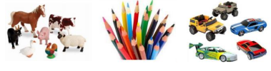  Use toys and general classroom resources for children to physically manipulate and regroup.  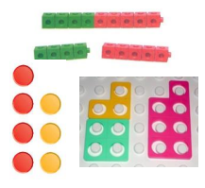  Use specific maths resources such as counters, cubes and Numicon.  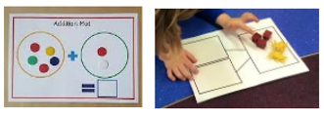  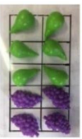  Use visual supports such as tens frames, part whole and addition mats with the physical objects and resources that can be manipulated.  Use fingers to support addition.  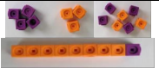  Use of cubes to add two numbers together as a group or in a bar. (Some children may still need to use real objects)  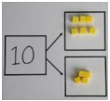  Use part whole model with objects – counters, cubes, numicon, sticks, everyday objects | 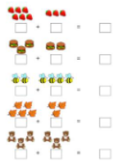    Two groups of pictures so children are able to count the total.  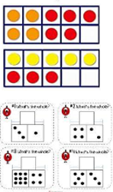  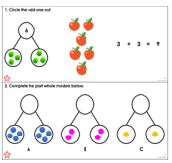  Use visual supports such as tens frames, part whole models and addition mats with pictures  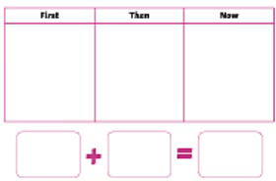  Use of first, now, then boards to solve addition problems  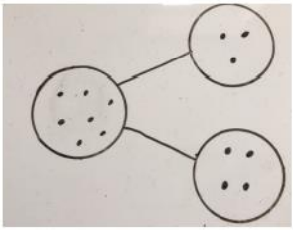  Use a part whole model with dots to represent the numbers  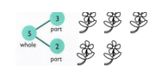  Use pictures to add two numbers together. | 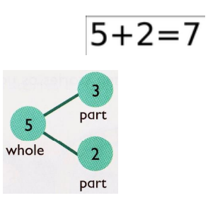  A focus on symbols and numbers to form calculations  - No expectation for children to record an addition calculation at this stage  4 + 3 = 7  Four is a part, 3 is a part, the whole is 7.  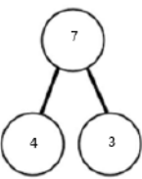
Represent and use number bonds and related subtraction facts within 20 | Use of tens frames with physical objects or double sided counters to represent numbers  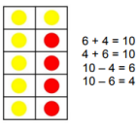  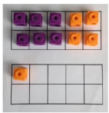 | Use of tens frames and part whole models with drawings of counters or dots to represent numbers  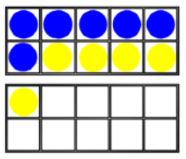  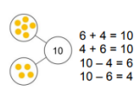 | Bar model and part whole model to be used alongside written calculation  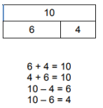

Addition and subtraction of one digit and two digit numbers to 20 | 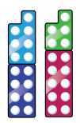  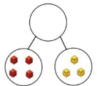  Start with the larger number and count on. Use of physical resources eg counters, double sided counters, cubes, Numicon, Base 10 to represent numbers | Start with larger number and use pictorial representations of numbers. Use dots/ circles in part wholes and tens frames. Draw sticks and stones to represent base 10. | Place the larger number in your head and count on the smaller number to find the answer.  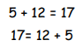
Regrouping to make ten | 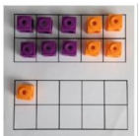  Use tens frames. Start with bigger number and use smaller number to make ten. | Use pictures to represent calculation.  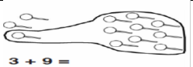  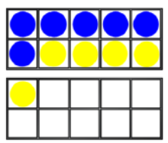  Draw onto a tens frame. | Children visualise regrouping mentally and form the number sentence  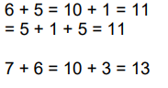
Adding 3 one digit numbers | 7 + 6 + 3  Look for number bonds to ten. Add seven and three, then count on six. Use counters or cubes on a tens frame.  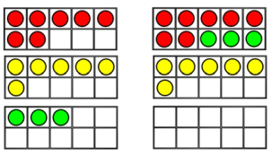  Use Numicon to make number bonds.  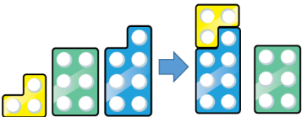 | Add together 3 groups of objects. Draw a picture to represent this. Look for number bonds to ten.  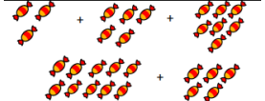  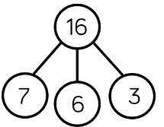  Draw dots or circles on tens frames to represent numbers.  Part whole models | 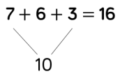  Combine the numbers that make ten and add on the remainder.  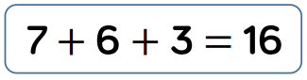  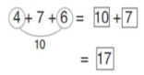
Add a two digit number and a one digit number | Use tens frame and double sided counters to make ten/ bridge through ten.  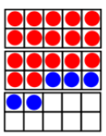  17 + 5 = 22 | 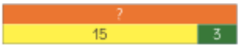  Use part whole model and bar model to help solve.  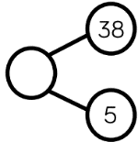  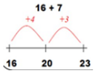  Use numberline to bridge through tens and count on. | 17 + 5 = 22  Explore related facts.  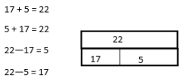
Adding a 2 digit number to a multiple of 10 | Use base 10 and place value counters to solve. Explore that the ones digit doesn’t change.  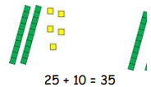 | Draw sticks and stones to represent numbers in calculations.  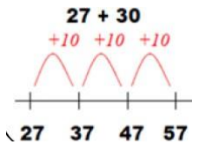  Use a numberline to show the calculation. | 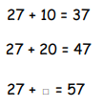
Add two 2 digit numbers with no regrouping | 24 + 15 =  Add together ones first then 10s in preparation for column method.  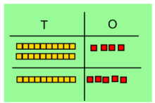  Use Base 10 first then move onto place value counters.  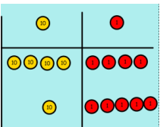 | 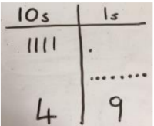  After practically using base 10 blocks and place value counters, children can draw the counters to help them solve additions.  41 + 8 =  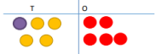  32 + 23 = | Record addition in columns supports place value and prepares for column method.  23  +32
Add two 2 digit numbers with regrouping | Use base 10 and place value counters on a place value grid to show the regrouping.  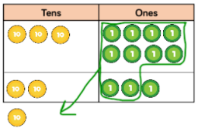  38 + 23  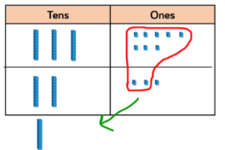 | 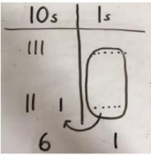  Draw sticks and stones to represent base 10 or draw place value counters  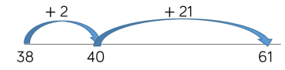  Use numberlines to count on – partitioning into tens and ones to count on and jumping to the next 10. | Use of formal method – column method  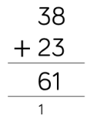
Add two numbers with up to 3 digits  (HTO + HTO or HTO + TO) | 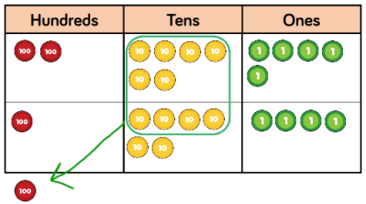  Use of base 10 or place value counters to add on a place value chart, regrouping can be shown  Children should be secure with place value counters before moving onto pictorial | 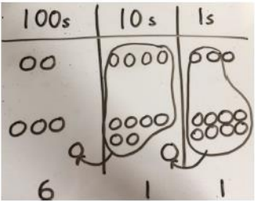  Children to draw place value chart and counters to represent numbers, circling when they make an exchange. | Column method with regrouping  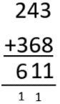  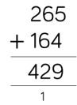
Add two numbers with four or more digits | Children continue to use base 10 and place value counters on a place value chart  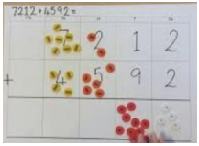 | Draw pictorial representations of place value chart with place value counters or base 10.  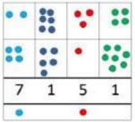 | Continue using column method with regrouping  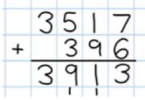

Subtraction

Key vocabulary: Subtract, minus, take away, fewer, less, find the difference, leave, difference between, how many left, how many more, count back, partition, ones, tens, hundreds, thousands, tens thousands, hundred thousands, millions, place value
Objectives | Concrete | Pictorial | Abstract
- Knows that a group of things change in quantity when something is taken away  - Find one less from a group of five objects, then ten objects.  - In practical activities and discussion, beginning to use the vocabulary involved in subtracting.  - Using quantities and objects, they subtract two single digit numbers and count back to find the answer. | 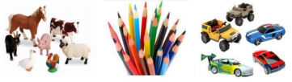  Use toys and general classroom resources for children to physically manipulate group/ regroup.  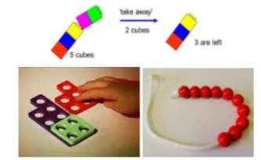  Use specific maths resources such as cubes, counters, Numicon etc  Use visual supports such as tens frames, subtraction mats and part whole models with physical objects that can be manipulated.  Use fingers to support subtraction | 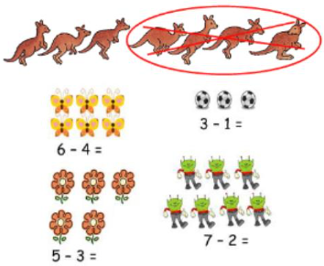  A group of pictures to cross out or cover quantities to support subtraction  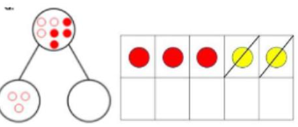  Use visual supports such as tens frames and part whole models with pictures/icons  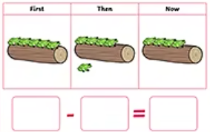  Use of first, then and now boards to support subtraction | 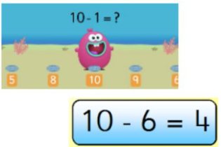  A focus on numbers and symbols to form subtraction calculations.  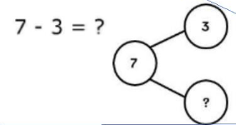  - No expectation for children to record a subtraction calculation at this stage
Subtract one-digit and two-digit numbers to 20, including 0.  Taking away ones | Physically taking away and removing objects from the whole (tens frames, Numicon, part whole models, cubes, counters etc)  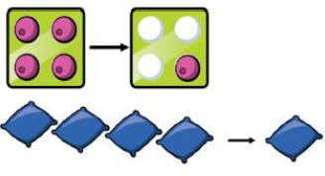 | 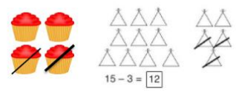  Cross out drawn objects to show what has been taken away | 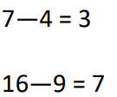
Subtract one-digit and two-digit numbers to 20, including 0.  Counting back | Use counters and move them away from the group counting backwards as you go  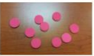 | 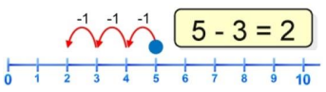  Count back on a numberline or track. Start at the bigger number and count back, counting the jumps  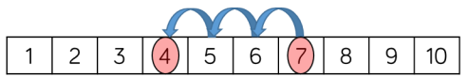 | Put 13 in your head and count back 4. What number are you at? (Use fingers to support)
Subtract one-digit and two-digit numbers to 20, including 0.  Find the difference | Compare objects and amounts  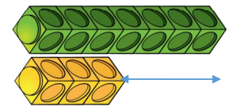  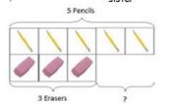  Lay objects in a bar model | Count on to find the difference  11 - 5 =  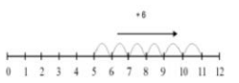  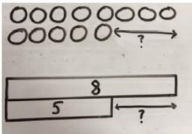  Draw cubes, counters or bars to find difference between two numbers | Find the difference between 8 and 5  8 – 5 =  The difference is….  Hannah has 12 sweets, Emma has 5 sweets. How many more does Hannah have?
Represent and use number bonds and related subtraction facts within 20  Part-part whole model | 10 – 6 = 4  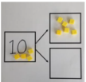  Link to addition using part whole model.  If 10 is the whole and 6 is a part, what is the other part? | Use a pictorial representation of a part whole model  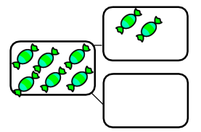 | Moving to numbers within the part whole model  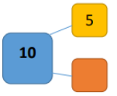
Represent and use number bonds and related subtraction facts within 20  Make 10 | 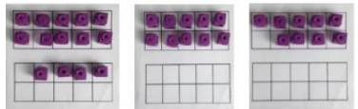  14 – 5 =  Make 14 on the tens frame. Take away your first four to make 10 and then take away one more so you have taken away 5. You are left with the answer of 9. | Children present the tens frame pictorially and discuss what they did to bridge ten.  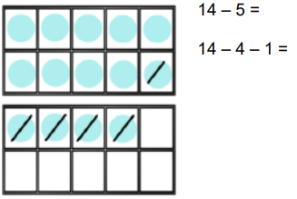  Use a numberline to subtract bridging 10.  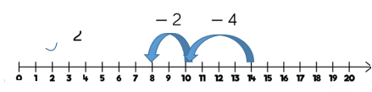  14 – 6 = | Children use partitioning to show how they make ten when subtracting  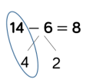
Subtract a two-digit number and ones, a two digit number and tens, two two-digit numbers  Partitioning to subtract without regrouping | Use base 10 on a place value chart and then physically removing the blocks  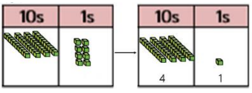  48 – 7 = | Represent the concrete objects pictorially  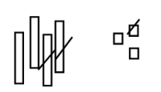  43 – 21 = 22  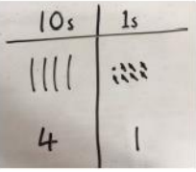  48 – 7 = 41 | Use of column method  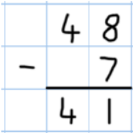
Column method for subtraction with regrouping/ exchanging | Children to represent the column method with concrete resources such as base 10 and having to physically exchange a ten for ten ones  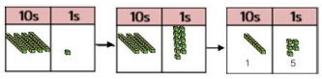  41 – 26 = | Children represent the concrete objects pictorially, remembering to show the exchange  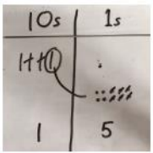  41 – 26 = | Formal column method is used. Children must understand that when they have exchanged the 10 they still have 41 because 41 = 30 + 11  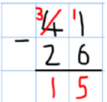
To subtract numbers with up to three-digits, using formal written methods of columnar subtraction | When dealing with bigger numbers, children can use place value counters for representation and physically exchanging  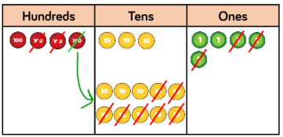  435 – 273 = 262 | Move onto representing place value counters pictorially, remembering to show what has been exchanged  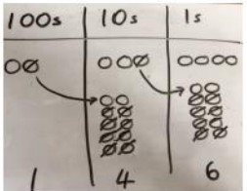  234 – 88 = | Formal column method is used. Children must understand what has happened when they cross out the numbers.  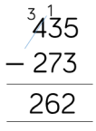
Subtract numbers with four or more digits | Continue using Base 10 and place value counters on place value charts to show exchange as above  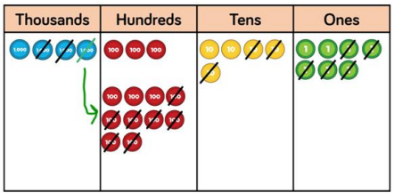 | Children find own way to pictorially represent calculation with exchange or regrouping | Continue to use formal written method of column subtraction as above  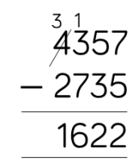
Introduce decimal subtraction through the context of money | Use place value charts with place value counters including tenths, hundredths and thousandths. Show exchanges as before. Ensure children understand that 1p = 1 hundredths and 10p = 1 tenth  £5.43 - £2.70 =  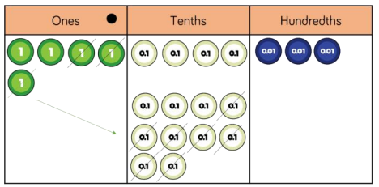 | Draw counters on place value charts as before, crossing out to show subtraction and any exchange  £5.43 - £2.70 =  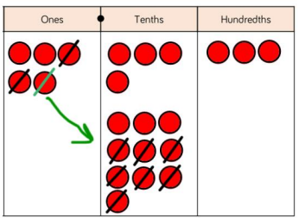 | Use formal written method of column method to subtract decimals.  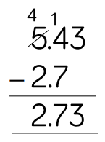

Multiplication

Key vocabulary: Multiply, times, groups of, lots of, repeated addition, times tables, inverse, doubling, halving, arrays, commutative, inverse, times as big as, myltiples of, scale up
Objectives | Concrete | Pictorial | Abstract
Solve problems including doubling | 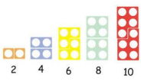  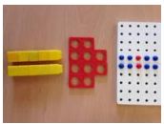  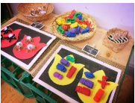  Counting and other maths resources (including tens frames) to make 2 equal groups.  Physical and real life examples that encourage children to see the concept of doubling as adding two equal groups | 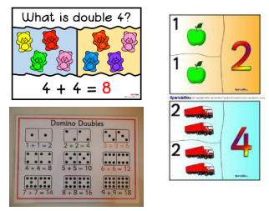  Pictures and icons that encourage children to see the concept of doubling as adding two equal groups | 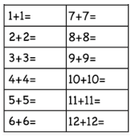  Addition calculations to model adding two equal groups  Counting in 10s, 5s and 2s
Doubling | Use practical activities including use cubes and Numicon to demonstrate doubling  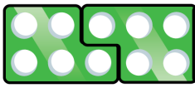  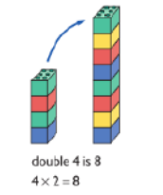 | 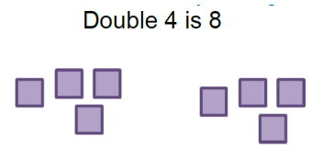  Draw pictures to show how to double a number. | Partition a number and double each part before recombining it back together  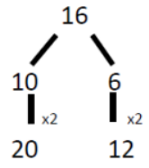
Counting in multiples | 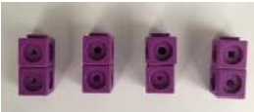  Count in multiples supported by concrete objects in equal groups.  4 x 2 = four groups of 2  2 + 2 + 2 + 2  There are 4 equal groups with 2 in each | 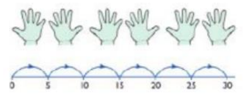  Use a numberline, bar model or pictures to support counting in multiples  Represent in bar model  Eg 3 x 4 is 3 lots of 4 = 4 + 4 + 4 = 12  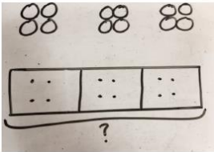 | Count in multiples of numbers aloud.  Write sequences of multiples with numbers  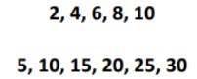
Repeated addition | 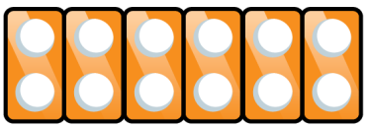  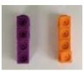  Use different objects to add equal groups | 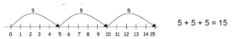  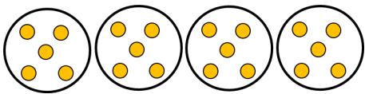  Use drawings or numberline to represent repeated addition  5+5+5+5 = 20 | Write addition number sentences to describe objects and pictures  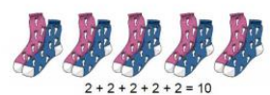
Understanding arrays for commutativity | Use objects to lay out in arrays eg counters, cubes  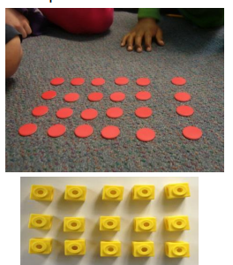 | Draw arrays in different ways to show commutative multiplication sentences  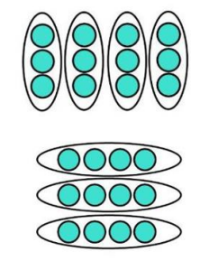 | Use arrays to write multiplication sentences and reinforce repeated addition  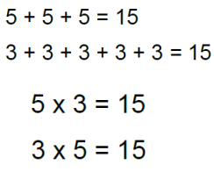
Using the inverse  Should be taught alongside division | Using objects in arrays to show groups of and sharing into groups  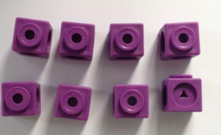 | 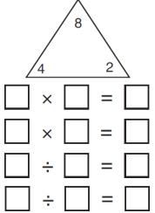 | Fact family sentences  2 x 4 = 8  4 x 2 = 8  8 = 4 x 2  8 = 2 x 4  8 ÷ 2 = 4  8 ÷ 4 = 2  4 = 8 ÷ 2  2 = 8 ÷ 4
Multiply 2 and 3 digit numbers by a 1 digit number  Start with grid method before progressing to formal written methods | Show the link between arrays to first introduce grid method  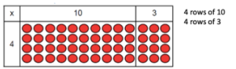  13 x 4  Move onto using Base 10 to show a more compact method  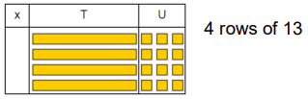  Move onto using place value counters to show how we are finding groups of numbers  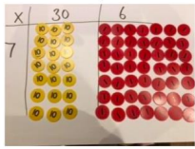  Add up each column, starting with the ones making any exchanges needed  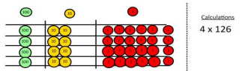 | Children can represent their work they have done with place value counters in a way that they understand.  Draw grid method with counters in the correct place value column  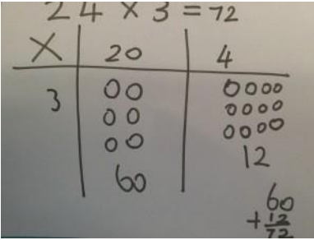 | Start with multiplying by one digit numbers and showing clear addition alongside the grid  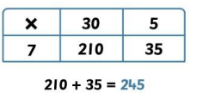  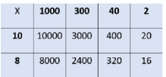
Column method for multiplication  This same process is used across KS2 for written multiplication objectives | Children can continue to be supported by use of place value counters or base 10 if necessary by this stage of multiplication. This is initially done with no regrouping.  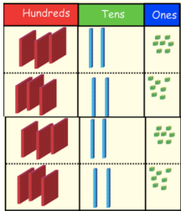  At this stage, always start by multiplying the ones first.  The corresponding long multiplication calculation is modelled along side. | The grid method can be used to show how this relates to a formal written method.  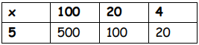 | 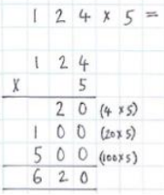  This leads to short multiplication being used.  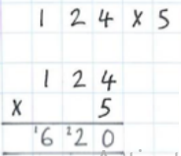
Multiply a decimal up to 2 decimal places by a single digit | As above using place value grid and place value counters | As above | 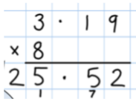  Remind children that the single digit belongs in the ones column. Line up the decimal points in the question and the answer

Division

Key vocabulary: Divide, division, divide by, share, groups of, equal groups, remainders, product, left over, divisible by, quotient, array, divisor, partitioning, commutative, inverse
Objectives | Concrete | Pictorial | Abstract
Solve problems including halving and sharing  Halving a whole, halving a quantity of objects  Sharing a quantity of objects | 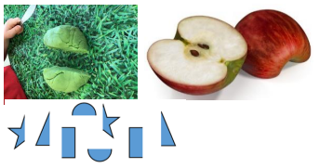  Children have the opportunity to physically cut objects, food or shapes in half  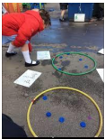  Counting and other maths resources for children to share into two equal groups  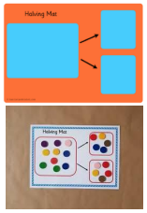  Use visual supports such as halving mats and part part whole, where physical objects and resources can be manipulated  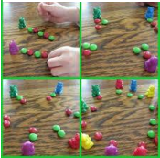  Counting and other maths resources for sharing between 3 or more groups | 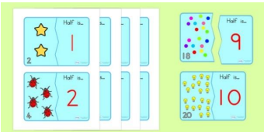  Pictures and icons that encourage children to see the concept of halving in relation to subitising, and addition and subtraction knowledge eg knowing 4 is made of 2 groups of 2, so half of 4 is 2.  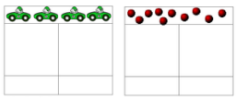  Bar model with pictures or icons to support understanding of finding 2 equal parts of a number to further understand how two halves make a whole.  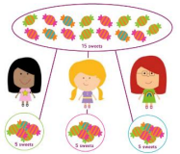  Pictures for children to create and visualise 3 or more equal groups
Sharing objects into groups | Sharing using a range of objects  6 ÷ 2  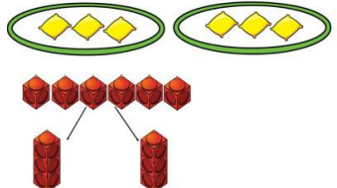  I have 10 cubes. Can you share them equally into two groups?  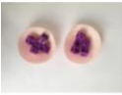  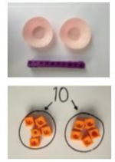 | Children show sharing pictorially  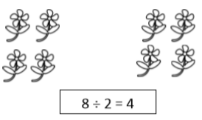  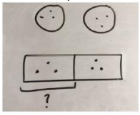  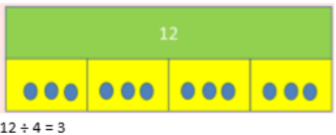  Children use bar modelling to show and support understanding | Share 9 buns between 3 people  9 ÷ 3 = 3  Children should be encouraged to use times table facts
Division as grouping | 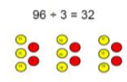  Divide quantities into equal groups using counters, cubes or objects  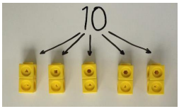 | Use a number line to show jumps in groups. The number of jumps equals the number of groups.  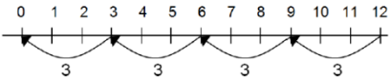  Think of the bar as a whole. Split it into the number of groups you are dividing by and work out how many would be in each group.  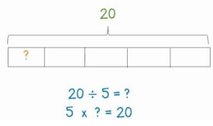 | Children can visualise grouping without concrete or pictorial support and develop knowledge of number fluency to be able to recall facts  28 ÷ 7 = 4
Division within arrays | 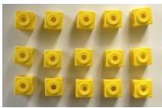  Link division to multiplication by creating an array and thinking about the numbers sentences that can be created eg  5 x 3 = 15 3 x 5 = 15  15 ÷ 3 = 5 15 ÷ 5 = 3 | Draw an array and use lines to split into groups to make multiplication and division sentences  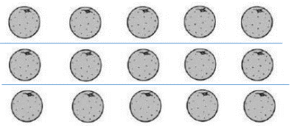 | Find the inverse of multiplication and division sentences by finding 4 linked number sentences  7 x 4 = 28  4 x 7 = 28  28 ÷ 7 = 4  28 ÷ 4 = 7
Divide 2 digit number by 1 digit number with no remainder | Use place value grids and place value counters to physically share  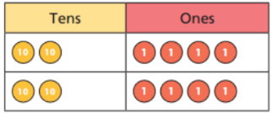  Use Base 10 to share into equal groups  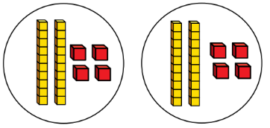 | As concrete but represent counters/ cubes/ base 10 or objects pictorially | 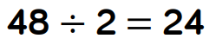
Divide 2 digits by 1 digit that includes an exchange between the tens and ones | Use place value grid with Base 10 or place value counters. Exchange the ten for ones when sharing into equal groups  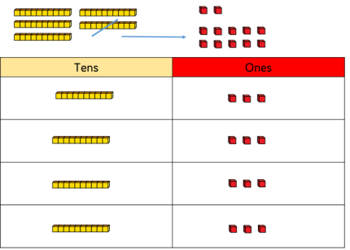  52 ÷ 4  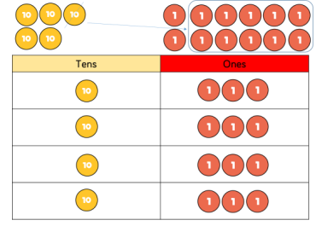 | As concrete but represent counters, cubes and Base 10 pictiorially.  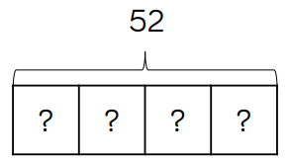  Use bar model to represent calculation  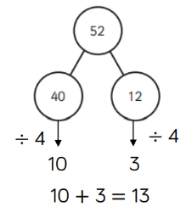  Flexible partitioning with part whole model | 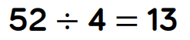
Division with remainders | Divide objects between groups and see how many are left over  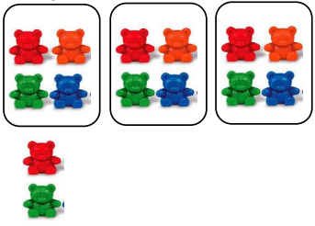  14 ÷ 3 = | 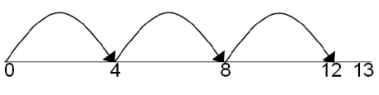  Jump forwards in equal groups on a number line then see how many more you need to jump for the remainder  Draw dots and group them to clearly show a remainder  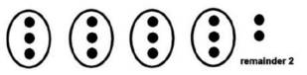 | Complete divisions and use r to show the remainder  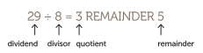
Divide up to 3 digits by 1 digit  Divide up to 4 digits by 1 digit  Short division | 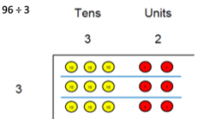  Use place value counters to divide using the bus stop method alongside  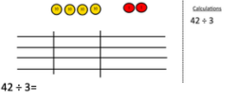  Start with biggest place value, we are sharing 40 between 3 groups. We can put 1 ten in each group and have 1 ten left over.  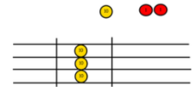  We exchange this ten for ten ones and then share the ones equally between each group.  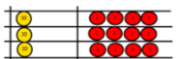  We look at how many are in each group. In this example the answer is 14. | Children can use dots and circles to draw diagrams to help them divide into groups.  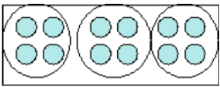  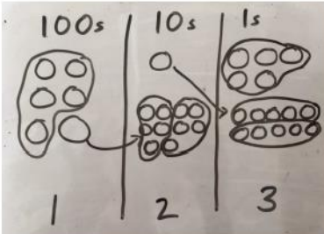  Children can also represent place value chart and groups pictorially | Children complete division calculation using short division method.  Begin with calculations that will divide equally with no remainders.  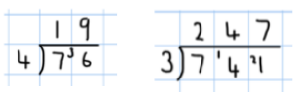  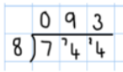  Children are aware that 0 is used as a place holder.  Move onto division with remainders  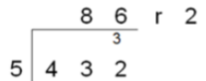
Long division | 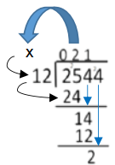  Abstract only  Once secure with short division children use following steps to long division. (concrete/pictorial do not apply). First use a step by step guide with X and – signs clearly displayed along with arrows showing the numbers being taken down.  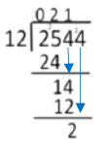  Remove the guide but leave arrows for digits that need to be taken down.  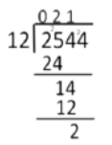  No guide required. Children can move on to working out decimal remainders and remainders as fractions.

